Explain the below linux commands with an example. Share the screenshot of each
command with the output:

1)pwd: pwd is used to know about the present working directory.it represent the present /print current working directory.
Full path of current working directory will be printed to standard output.
$pwd

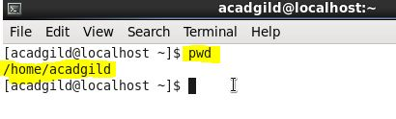
In the above example we use pwd and it tells about our present working directory which is /home/acadgild that means we are currently working in acadgild which is present inside home directory

2)Vi: vi is an editor where we can edit some thing and create a file also.
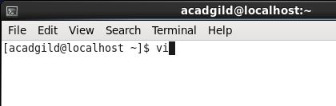
Through above command we go to vi editor
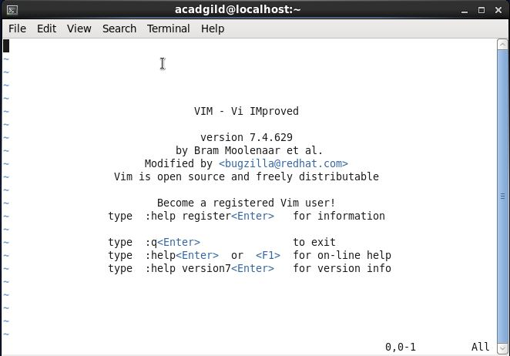

We can give any file name with vi ,and can create new or edit the old one

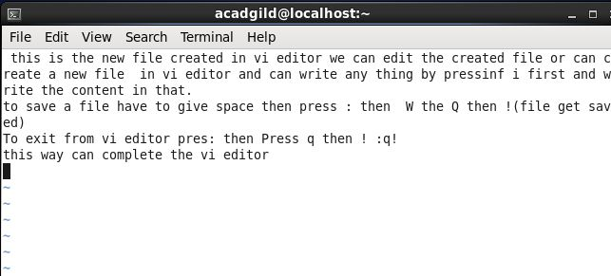

For writing or editing some file have to press i before doing this
Then can write the content
To save any file in vi editor have to type :WQ! Followed by a space
To exit from editor have to write :q!
Can see the content of file by using ls command
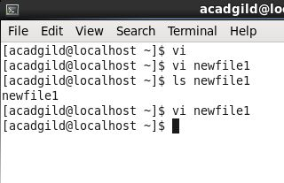
What all is present in that file will be shown there.

3)Touch : Touch changes the file timestamp.
Updates the access and modification time of each file to the current system time.
If we specify a file that doesnot exists touch create an empty file with that name,unless (-c,-h options are specified)
-a: changes only access time.
-c ,--no-create: donot create any file.
-d: prase the string and use it instead of current time.
-f: ignored but included for compatibility reasons.
-m: change the modification time
Touch nikky: will create a file nikky with zero byte
Touch nikky shhen meena : will create multiple files.
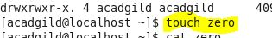

Used for
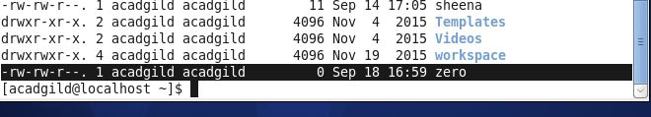

4)Mkdir: To make a directory on a file system.
If doesnot exist create it.
User can read write and execute.
Owner groups and user all can have all three permissions i.e read write and execute.
For read:4
Write:2
Execute:1
If we want to create any directory at any location and that doesnot exist ,so will crete tht first.
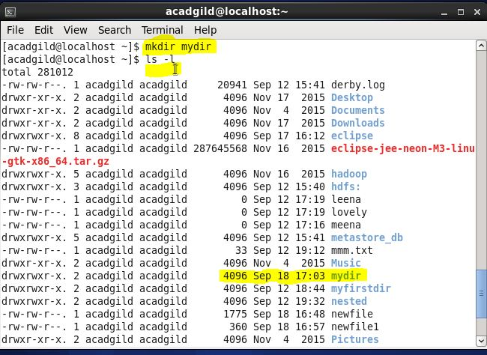
5)Rm: used to remove a file or directory.RM removes specified file not directories.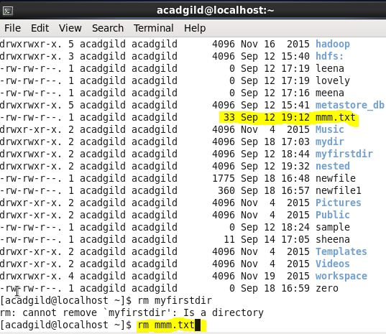
After this when we see all the file using ls command ,mmm will not be there
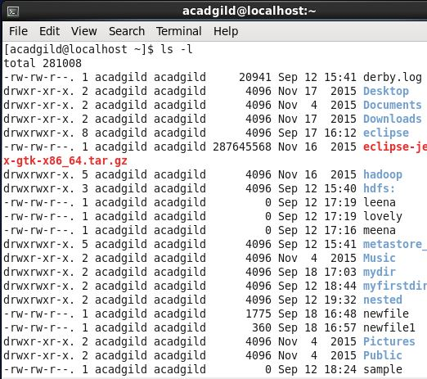

6)Ls: All the data are organized into files in unix and all files are organized into directories
And directories are organized into treelike structure called FileSystem.
Can also use ls command to list out all the foles or dorectories available in directory(current).

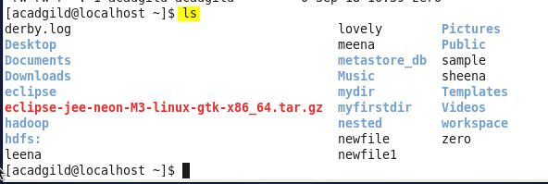

7)Echo:Echo offers command line frequently used in script ,batch files and part of individuals commands.
$echo”hello world”→To print string in console.
\b→backspace
-e→remove all space
\n → new line
\t → horizontal tab
\v →Vertical line
\r → carriage return

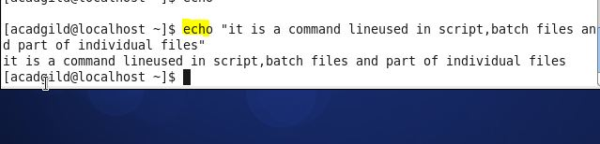

8)Cat: Allow us to create single or multiple file,view content of file,concatenate file and redirect output in terminal files.
Display what is there in sample.txt→ $cat sample.txt
Display all txt files → $cat*.txt
Concatenate two files →$cat sample.txt sample2.txt>sample3.txt
To put content of file in a variable:→$variable_content= ‘cat sample.txt’

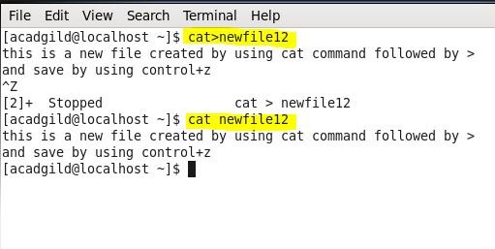
9)Who: Displays who is logged on to the system. The who command prints information about all users who are currently logged in.
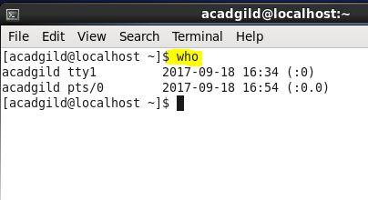

10)Cd: change directories.
Change current working dorectort to specific folder
Move to sample folder→cd/usr/local/sample
Check using pwd
$pwd→/usr/local.sample
Quickly get back→$cd
Move up one folder→$cd..
Get back to oroginl location→$cd
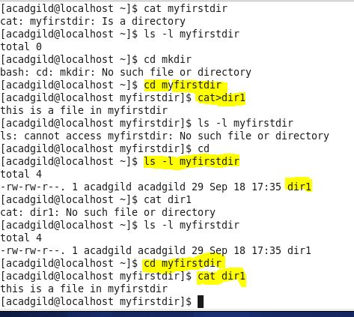

11)Date: Display the current date and time.
%% → A literal % sign $date +%a
%a →week dat name(sun)
%A → full weekday name(MONDAY)
%b →month name (jan)
%B → full month name (JANUARY)
Date “+DATE : %m/%d/%y%n Time:%H:%M:%s”
Date -s
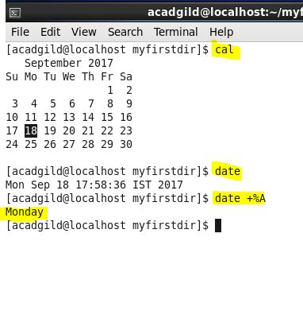

12)Cal: To check the calenderwillshow the present date.

13)Mv:To move or rename a file
Rename source to destination or move source file to directory.
Mv myfile.txt destination –directory(movinf a file to directory)
Attempt to movr into parent directory→ mv myfile.txt../
Rename→mv computer\hope.txt comport\hope2.txt

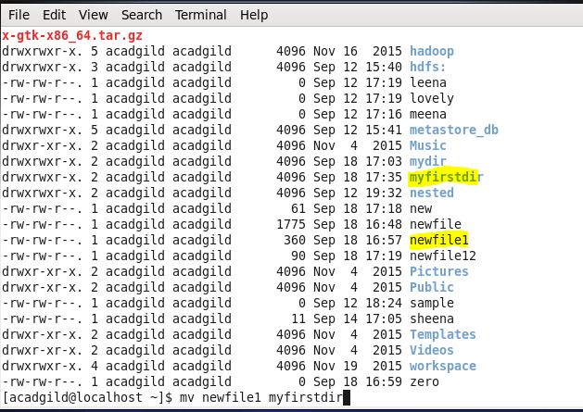

14)Cp: To copy one or more file to another location
$ cp sample.txt Apple.txtcopy sample directory to home directory
$ cp –f /user/sample/*>

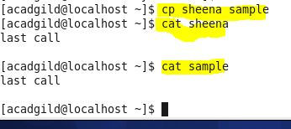

15)Which: Locate the executable file associated with the given command.
Syntax: which –a[filename]..
Print all matching pathname of each matching filename
0→filename found and executable
1→ one or more not found and not executable
2→invalid option

